Experiment Number : 8 Date: 24/02/2026

Implementation of Packages in Java

Aim:
Write a Java program to implement built-in, user-defined packages and accessing all classes in a package.

PRE LAB EXERCISE
QUESTIONS
- What is java.util package and what collection framework does it contain?
- java.util is a built-in Java package that contains utility classes and interfaces.
- It includes important classes for collections, date & time, random numbers, and data structures.
- The Collection Framework inside java.util provides ready-made data structures such as:
- List – ArrayList, LinkedList, Vector
- Set – HashSet, LinkedHashSet, TreeSet
- Queue – PriorityQueue, Deque
- Map – HashMap, LinkedHashMap, TreeMap
- What are the two types of packages in Java?
Built-in (Predefined) Packages
- Already provided by Java.
- Examples: java.lang, java.util, java.io.
User-defined Packages
- Created by the programmer to organize their own classes.

IN LAB EXERCISE
Objective
To understand and implement the concepts of built-in, user-defined packages and accessing all classes in a package in Java.
Built-in Packages comprise a large number of classes that are part of the Java API. Some of the commonly used built-in packages are:
- java.lang: Contains language support classes(e.g, classes that define primitive data types, math operations). This package is automatically imported.
- java.io: Contains classes for supporting input/output operations.
- java.util: Contains utility classes that implement data structures such as Linked Lists and Dictionaries, as well as support for date and time operations.
- java.applet: Contains classes for creating Applets.
- java.awt: Contains classes for implementing the components for graphical user interfaces (like buttons, menus, etc).
Source Code
import java.util.Random; // built-in package
public class Sample{
public static void main(String[] args) {
// using Random class
Random rand = new Random();
// generates a number between 0–99
int number = rand.nextInt(100);
System.out.println("Random number: " + number);
}
}
Output
Random number: 49
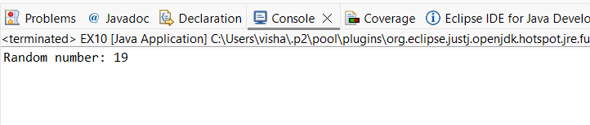

User-defined Packages are the packages that are defined by the user.
Source code
package com.myapp;
public class Helper {
public static void show() {
System.out.println("Hello from Helper!");
}
}
==To use this in another class==
import com.myapp.Helper;
public class Test {
public static void main(String[] args) {
Helper.show();
}
}

Output:
Hello from Helper!
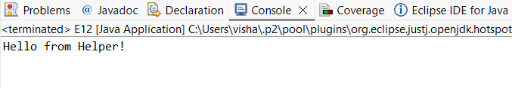
//Importing all classes from a package.
Source code
import java.util.Vector;
public class Coders {
public Coders() {
// java.util.Vector is imported, We are able to access it directly in our code.
Vector v = new Vector();
java.util.ArrayList l = new java.util.ArrayList();
l.add(3);
l.add(5);
l.add(7);
System.out.println(l);
}
public static void main(String[] args) {
new Coders();
}
}
Output
[3,5,7]
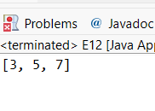
POST LAB EXERCISE
- What will happen if two classes in different packages have the same name and are imported in a Java file?

If two classes have the same name and both are imported:
- Java will get confused
- It will show a compile-time error (ambiguous reference)
Solution:
Use the full package name while using the class.

- What is the purpose of using packages in Java?
Packages are used to:
- Organize classes properly
- Avoid name conflicts
- Make code easy to manage
- Provide security and access control
Simple:
Packages help keep Java programs neat and structured.

- Which built-in Java package would you use if you want to create a GUI window and display a message?
- java.util
- java.sql
- java.awt
- java.net
Correct Answer: C. java.awt
- java.awt is used for GUI (buttons, windows, labels, etc.)
- Example: Frame, Button, Label

ASSESSMENT

Description | Max Marks | Marks Awarded
Pre Lab Exercise | 5
In Lab Exercise | 10
Post Lab Exercise | 5
Viva | 10
Total | 30
Faculty Signature

Experiment Number : 9 Date:24/02/2026

Implementation of a Java Program to import packages using different methods

Aim:
Write a Java program to import packages using different methods for different use cases.

PRE LAB EXERCISE
QUESTIONS
- How to import a single class and multiple classes from a package in Java?
- Import a single class
Use the class name.
Example:
- import java.util.ArrayList;
- This imports only ArrayList class.
- Import multiple classes (all classes)
Use * (star).
- Example:
- import java.util.*;
- This imports all classes from java.util package.
Simple:
- Single class → class name
- Multiple classes → *

- Which package is always imported by default in every Java class?
Answer: java.lang
This package is automatically imported.
It contains important classes like:
- String
- System
- Math
- Integer
Example:
You can use System.out.println() without importing because it is in java.lang.

IN LAB EXERCISE
Objective
To understand and implement the Java packages using different methods and import them.
Problem
Define a package named ‘useFul’ with a class names ‘UseMe’ having following methods:
1) area()- To calculate the area of given shape.
2) salary()- To calculate the salary given basic Salary,da,hRA.
3) percentage()-To calculate the percentage given total marks and marks obtained.
4) Develop a program named ‘Package Use’ to import the above package ‘useFul’ and use the method area().
5) Develop a program named ‘manager’
Source Code
//Package Creation:
package useFull;
import java.util.*;
public class UseMe
{
Scanner obj=new Scanner(System.in);
public static void area()
{
class method{
void aos(int a)
{
System.out.print("\nArea of square with length "+a+" is "+(a*a));
}
void aor(int a,int b)
{
System.out.print("\nArea of reactangle with dimensions "+a+" & "+b+" is "+(a*b));
}
void aoc(int r)
{
double a=3.14*r*r;
}
System.out.print("\nArea of circle with radius "+r+" is "+a);
}
void aot(int a,int b)
{
float ar=(a*b)/2;
System.out.print("\nArea of triangle with dimensions "+a+" &"+b+" is "+ar);
} }
Scanner obj=new Scanner(System.in);
method m=new method();
System.out.print("\n1.Square\n2.Rectangle\n3.Circle\n4.Triangle\nSelect the shape\n");
int ch=obj.nextInt();
UseMe u=new UseMe();
switch(ch)
{
case 1:System.out.print("\nEnter the length of side of square : ");
int s=obj.nextInt();m.aos(s);
break;
case 2:System.out.print("\nEnter the dimensions of rectangle : ");
int l=obj.nextInt();
int b=obj.nextInt();
m.aor(l,b);
break;
case 3:System.out.print("\nEnter the radius of circle : ");
int r=obj.nextInt();
m.aoc(r);
break;
case 4:System.out.print("\nEnter the dimensions of triangle : ");
int ba=obj.nextInt();
int w=obj.nextInt();
m.aot(ba,w);
break; } }
public void salary()
{
int ba,da,hra;
System.out.print("\nEnter the basic salary : ");
ba=obj.nextInt();
System.out.print("\nEnter the dearness allowance :");
da=obj.nextInt();
System.out.print("\nEnter the house rent allowance : ");
hra=obj.nextInt();
System.out.print("\nThe total Gross salary of employee is : "+(ba+da+hra));
}
public void percentage()
{
int n,sum=0;
float p;
System.out.print("\nEnter the total number of subjects : ");
n=obj.nextInt();
int m[]=new int[n];
System.out.print("\nEnter the marks of "+n+" subjects : ");
for(int i=0;i<n;i++)
{
m[n]=obj.nextInt();
}
for(int i=0;i<n;i++)
{
sum=sum+m[i];
}
p=sum/n;
{
System.out.print("\nPercentahe of student : "+p);
}
}
}
//Package Implementation-1:
import useFull.UseMe;
class packageUse
{
public static void main(String args[])
{
UseMe o=new UseMe();o.area();
}
}

Output
javac packageUse.java
java packageUse
- Square
- Rectangle
- Circle
- Triangle
Select the shape
2

Enter the dimensions of the rectangle: 10 15
Area of the rectangle with dimensions 10&15 is 150
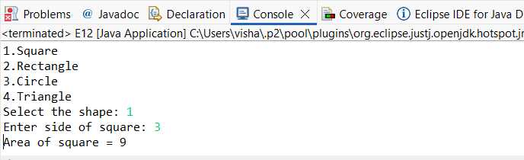
//Package Implementation-2:
import useFull.UseMe;
class manager
{
public static void main(String args[])
{
UseMe obj=new UseMe();obj.salary();
}
}

Output
javac manager.java
java manager

Enter the basic salary: 100000
Enter the dearness allowance: 5000
Enter the house rent allowance: 2000
The total Gross salary of employee is: 107000
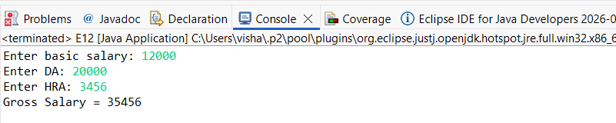

POST LAB EXERCISE
- Find the key differences between java.util and java.lang packages.
java.lang | java.util
Automatically imported | Must be imported manually
Contains basic language classes | Contains utility classes
Used for core features | Used for data structures & helper tools

- List some of the subpackages of java.util
Some important subpackages are:
- java.util.concurrent → For multithreading
- java.util.function → Functional interfaces
- java.util.logging → Logging system
- java.util.regex → Regular expressions
- java.util.stream → Stream API

ASSESSMENT

Description | Max Marks | Marks Awarded
Pre Lab Exercise | 5
In Lab Exercise | 10
Post Lab Exercise | 5
Viva | 10
Total | 30
Faculty Signature

Experiment Number : 10 Date: 26/02/2026

Implementation of Access Modifiers in Java

Aim:
Write a Java program to implement different access modifiers.

PRE LAB EXERCISE
QUESTIONS
- What are the 4 access modifiers available in Java?
- public
- protected
- default
- private

- Which access modifiers can be used in Java to control access to class members?
For class members (variables, methods, constructors), all 4 can be used:
- public
- protected
- default
- private
They control how and where the members can be accessed.

IN LAB EXERCISE
Objective
To demonstrate different access modifiers such as Default, Private, Protected and Public using Java programs.
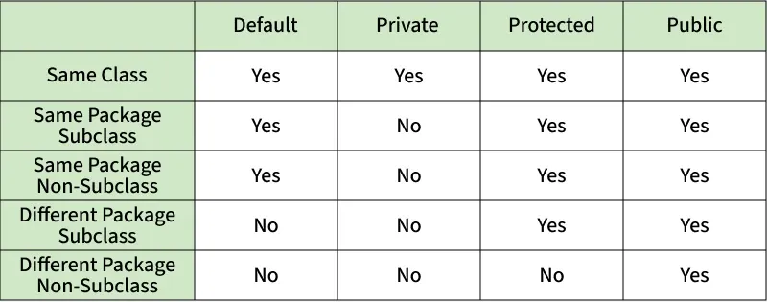
Fig: Comparison table of Access Modifiers in Java
Source Code
// Default Access modifier
class Car {
String model; // default access
}
public class Main {
public static void main(String[] args){
Car c = new Car();
c.model = "Tesla"; // accessible within the same package
System.out.println(c.model);
}
}
Output:
Tesla
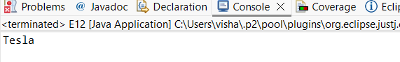

//Private Access Modifier
class Person {
// private variable
private String name;
public void setName(String name) {
this.name = name; // accessible within class
}
public String getName() {
return name;
}
}
public class Geeks {
public static void main(String[] args)
{
Person p = new Person();
p.setName("Alice");

// System.out.println(p.name);
// Error: 'name'
// has private access
System.out.println(p.getName());
}
}
Output
Alice
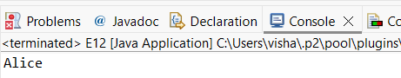

//Protected Access Modifier
class Vehicle {
protected int speed; // protected member
}
class Bike extends Vehicle {
void setSpeed(int s)
{
speed = s; // accessible in subclass
}
int getSpeed()
{
return speed; // accessible in subclass
}
}
public class Main {
public static void main(String[] args){
Bike b = new Bike();
b.setSpeed(100);
System.out.println("Access via subclass method: "+ b.getSpeed());
Vehicle v = new Vehicle();
System.out.println(v.speed);
}
}
Output
Access via subclass method: 100
0
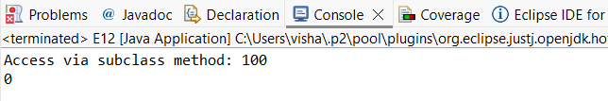

//Public Access Modifier
class MathUtils {
public static int add(int a, int b) {
return a + b;
}
}
public class Main {
public static void main(String[] args) {
System.out.println(MathUtils.add(5, 10)); // accessible anywhere
}
}
Output
15
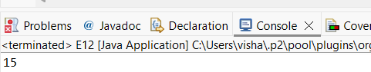

POST LAB EXERCISE
  - Write a Java program to implement Default access modifier which has a default class within the same package and a default class from a different package.
• Default access modifier = No keyword
• Accessible only within the same package
• Not accessible from different package

  - Which access modifier provides the highest level of access?
Answer: public
Explanation:
- public members can be accessed from anywhere
- Inside class
- Same package
- Different package
- Subclasses

Access Level Order (Highest → Lowest Access)
- public → Everywhere
- protected → Same package + subclass
- default → Same package only
- private → Same class only

ASSESSMENT

Description | Max Marks | Marks Awarded
Pre Lab Exercise | 5
In Lab Exercise | 10
Post Lab Exercise | 5
Viva | 10
Total | 30
Faculty Signature

Experiment Number :11 Date: 26/02/2026

Implementation of multiple inheritance in Java using Interface

Aim:
Write a Java program to implement multiple inheritance using Interface.

PRE LAB EXERCISE
QUESTIONS
- Why Java does not support multiple inheritance using classes like that of C?

Reason: To avoid ambiguity (Diamond Problem)
If a class inherits from two classes, and both parent classes have the same method, the child class gets confused about:
Which method to use?
This problem is called the Diamond Problem.

- What is the primary purpose of an interface in Java?
- To store data using instance variables
- To define a contract of methods a class must implement
- To allow creation of objects
- To improve runtime performance
To define a contract of methods a class must implement
Explanation:
An interface:
- Contains method declarations
- A class that implements the interface must define those methods
- Acts like a contract

IN LAB EXERCISE
Objective
To demonstrate how an interface in Java defines constants and abstract methods, which are implemented by a class.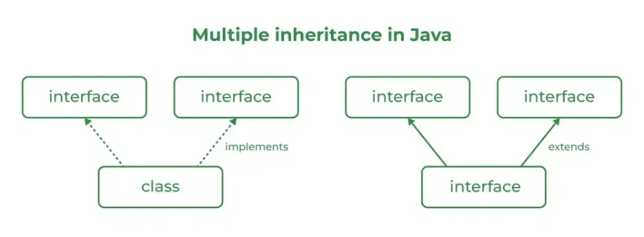

Source Code
import java.io.*;
// Add interface
interface Add{
int add(int a,int b);
}
// Sub interface
interface Sub{
int sub(int a,int b);
}
// Calculator class implementing Add and Sub
class Cal implements Add , Sub
{
// Method to add two numbers
public int add(int a,int b){
return a+b;
}
// Method to sub two numbers
public int sub(int a,int b){
return a-b;
}
}
class Example{
// Main Method
public static void main (String[] args){

// instance of Cal class
Cal x = new Cal();
System.out.println("Addition : " + x.add(2,1));
System.out.println("Substraction : " + x.sub(2,1));
}
}

Outputs
Addition : 3
Subtraction : 1
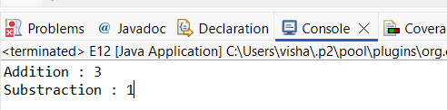

POST LAB EXERCISE
  - Can a functional interface extend another interface?
Yes, it can.
But there is one condition:
- After extending, it must still have only one abstract method.
If it has more than one abstract method, it is not a functional interface.

  - Which feature was introduced in interfaces starting from Java 8?
- Constructors
- Private methods
- Default and static methods
- Final classes
Correct Answer:
C. Default and static methods
Before Java 8:
- Interfaces could have only abstract methods.
From Java 8:
- Interfaces can have:
  - Default methods
  - Static methods
These allow method implementation inside interfaces.

ASSESSMENT

Description | Max Marks | Marks Awarded
Pre Lab Exercise | 5
In Lab Exercise | 10
Post Lab Exercise | 5
Viva | 10
Total | 30
Faculty Signature

Experiment Number : 12 Date: 26/02/2026

Implementation of exception handling in Java
Aim:
Write a java program to implement exception handling.

PRE LAB EXERCISE
QUESTIONS
- What is exception handling in Java?
Definition:
Exception handling is a mechanism in Java used to handle runtime errors so that the program does not crash.
Explanation:
- When an error occurs during program execution, it is called an exception.
- Exception handling allows the program to handle the error and continue running normally.
Example:
Dividing a number by zero causes an error.
Using exception handling, we can display a message instead of stopping the program.

- What is the purpose of using try-catch blocks in exception handling?
Purpose:
The try-catch block is used to catch and handle exceptions.
How it works:
try {
// code that may cause error
}
catch(Exception e) {
// code to handle error
}
- try → Contains risky code (may cause exception)
- catch → Handles the error if it occurs

Why we use it?
- Prevents program from crashing
- Handles runtime errors properly
- Maintains normal program flow
- Displays user-friendly error messages

IN LAB EXERCISE
Objective
To understand and implement exception handling through try-catch and finally blocks.
Source Code
import java.util.InputMismatchException;
import java.util.Scanner;
public class ExceptionHandlingExample {
public static void main(String[] args) {
Scanner scanner = new Scanner(System.in);
try {
System.out.print("Enter an integer: ");
int num = scanner.nextInt();
int result = 10 / num;
System.out.println("Result: " + result);
} catch (InputMismatchException e) {
System.out.println("Invalid input! Please enter an integer.");
} catch (ArithmeticException e) {
System.out.println("Cannot divide by zero!");
} finally {
scanner.close();
System.out.println("Program execution completed.");
} }
}
Outputs
Output 1 (Valid Input - Non-zero Integer):
Enter an integer: 5
Result: 2
Program execution completed.

Output 2 (Valid Input - Zero):
Enter an integer: 0
Cannot divide by zero!
Program execution completed.

Output 3 (Invalid Input - Non-integer):
Enter an integer: abc
Invalid input! Please enter an integer.
Program execution completed.
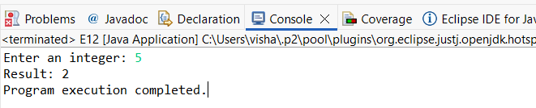
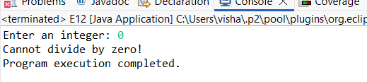
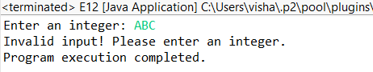

POST LAB EXERCISE
- What is the purpose of the Scanner object in the Java program?
Purpose:
The Scanner object is used to take input from the user.
In this program:
Scanner scanner = new Scanner(System.in);
- System.in → takes input from keyboard
- scanner.nextInt() → reads an integer entered by the user
So, Scanner helps the program read user input.

- What exceptions are expected to be thrown in the code within the try block? Why?
Inside the try block:
int num = scanner.nextInt();
int result = 10 / num;
Two exceptions may occur:

InputMismatchException
Happens when user enters:
- A string (example: "abc")
- A decimal number
- Any non-integer value
Because nextInt() expects an integer.

ArithmeticException
Happens when user enters:
- 0
Because dividing by zero is not allowed:
10 / 0

Final Answer:
- Scanner is used to take input from the user.
- Expected exceptions:
  - InputMismatchException → if user enters non-integer
  - ArithmeticException → if user enters 0 (divide by zero)

ASSESSMENT

Description | Max Marks | Marks Awarded
Pre Lab Exercise | 5
In Lab Exercise | 10
Post Lab Exercise | 5
Viva | 10
Total | 30
Faculty Signature

Experiment Number : 13 Date: 26/02/2026
Implementation of User-defined Exception in Java

Aim:
Write a java program to implement User-defined Exception.

PRE LAB EXERCISE
QUESTIONS
- What is Java custom exception?
A custom exception is a user-defined exception created by the programmer.
It is used to handle specific errors according to program requirements.
Why we use it?
- To create our own error messages
- To handle application-specific problems

- What are the two types of custom exceptions in Java?
1. Checked Custom Exception
- Extends Exception
- Checked at compile time
- Must be handled using try-catch or throws
Example:
class MyException extends Exception { }
2. Unchecked Custom Exception
- Extends RuntimeException
- Not checked at compile time
- Handling is optional
Example:
class MyException extends RuntimeException { }

IN LAB EXERCISE
Objective
To understand and implement Checked and Unchecked custom exceptions.
Source Code
Ex 1: // Custom Checked Exception
class InvalidAgeException extends Exception {
public InvalidAgeException(String m) {
super(m);
}
}
// Using the Custom Exception
public class AgeCheck{
public static void validate(int age)
throws InvalidAgeException {
if (age < 18) {
throw new InvalidAgeException("Age must be 18 or above.");
}
System.out.println("Valid age: " + age);
}
public static void main(String[] args) {
try {
validate(12);
} catch (InvalidAgeException e) {
System.out.println("Caught Exception: " + e.getMessage());
}
}
}

Output 1
Caught Exception: Age must be 18 or above.
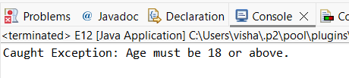

Ex 2: // Custom Unchecked Exception
class DivideByZeroException extends RuntimeException {
public DivideByZeroException(String m) {
super(m);
}
}
// Using the Custom Exception
public class TestSample {
public static void divide(int a, int b) {
if (b == 0) {
throw new DivideByZeroException("Division by zero is not allowed.");
}
System.out.println("Result: " + (a / b));
}
public static void main(String[] args) {
try {
divide(10, 0);
} catch (DivideByZeroException e) {
System.out.println("Caught Exception: " + e.getMessage());
}
}
}

Output 2
Caught Exception: Division by zero is not allowed.
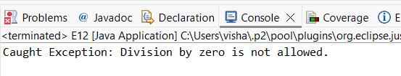

POST LAB EXERCISE
- What is required to create a custom exception in Java?
- Extend the Object class
- Extend the Throwable class
- Extend Exception or RuntimeException
- Implement the Serializable interface
Correct Answer:
C. Extend Exception or RuntimeException
Explanation:
To create a custom exception, you must:
- Extend Exception → for checked exception
- Extend RuntimeException → for unchecked exception
Example:
class MyException extends Exception {
public MyException(String message) {
super(message);
}
}

- List some use cases for the checked and unchecked exceptions.
Checked Exceptions
(Checked at compile time)
Use when:
- Error can be expected
- Programmer must handle it
Examples:
- File not found
- Database connection error
- Network error
- Invalid user input (like file reading)
Example: IOException, SQLException
Unchecked Exceptions
(Not checked at compile time)
✔ Use when:
- Programming mistake
- Logical error
Examples:
- Divide by zero
- Null pointer access
- Array index out of bounds
Example: ArithmeticException, NullPointerException

ASSESSMENT

Description | Max Marks | Marks Awarded
Pre Lab Exercise | 5
In Lab Exercise | 10
Post Lab Exercise | 5
Viva | 10
Total | 30
Faculty Signature

